**CVWO 2019/2020 Mid-assignment**

By: Andre Wong Zhi Hua

**Frontend Using React:**

NPM packages include:

* React-router
* Redux
* Redux-thunk
* Semantic-ui-react
* Axios

There will be 4 routes that will be managed by react-router:

* one as the homepage (“/”)
* one to add a new task (“/add”)
* another to update a todo (“/edit/:id”)
* and the last one to display the todos in a different manner (“/focus”)

React components will be styled using semantic-ui-react and semantic-ui-css.

There will be a central state managed by redux whereby all the components can access. This includes all the todos data from database, loading logic, navigation and messages to inform users once they done an operation.

Redux-thunk is used to make a call asynchronously to the backend in order to fetch data from the database. Axios is used to make http request to the backend and retrieve json data from backend.

**Backend using Rails 6**

There will be 4 routes that we will listen to:

* (GET /todos) which will receive all the todos from the database
* (POST /todos) which will create a new todo and store in the database
* (PUT /todos/:id) which will update a particular todo of that id
* (DELETE /todos/:id) which will delete a particular todo of that id

This will form the basic CRUD app of our assignment

**Database using sqlite3**

There are 6 information that we will save:

* Title as string
* Created as date
* Deadline as date
* Desc as text
* Done as Boolean
* Tag as string

Database:

| ID | title | description | created on| Deadline | tags | done|

**Current progress:**

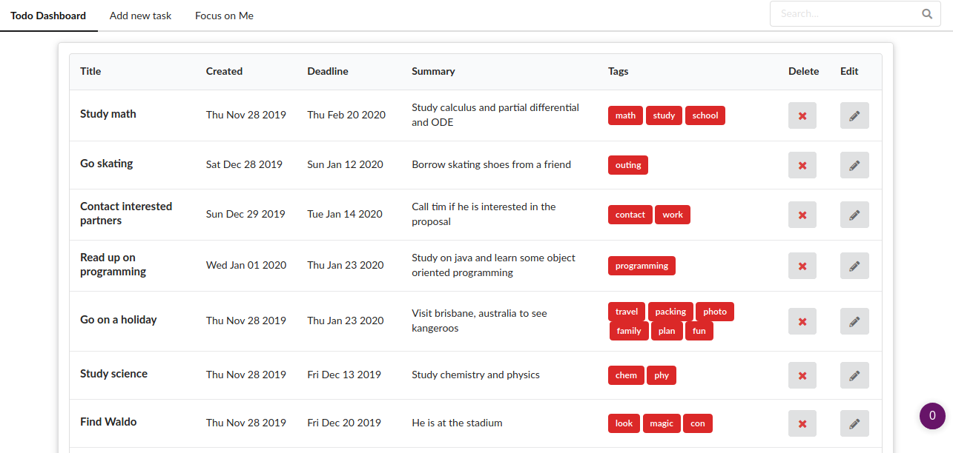

This is the current homepage for displaying all the todos, I have connected the frontend to the backend by making API calls

One difficult I faced was that the homepage is rendered empty. This is due to the API calls that has not finished receiving the data yet, as such no todos is being displayed. This is caused by the method render() being executed first before componentDidMount(), and one solution to circumvent this problem is to introduce a loading screen first while the data is being fetched.

One feature to implement is the filter and search function via title, description or tags. This will most likely be done via query parameters to the backend so that sqlite3 can sort and filter for us.

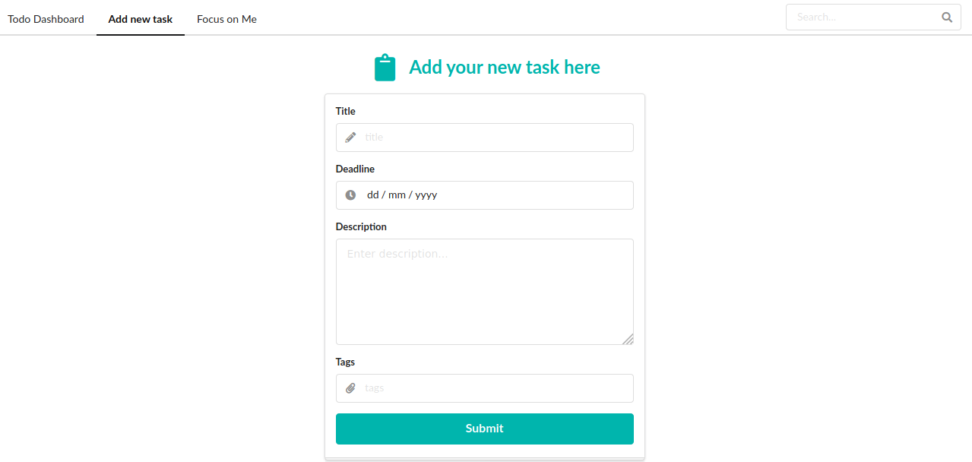

This is the UI for adding a new task.

One improvement would be changing the ui such that adding of tags will be more user friendly. Right now, the tags have to be delimited by a comma.